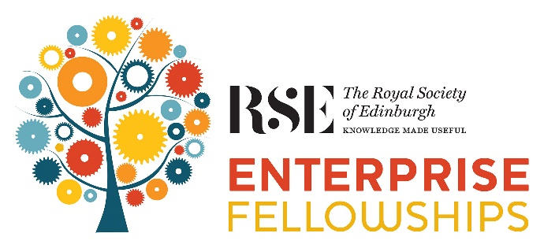

Application Form

Deadline for Applications & References

5pm, 3 April 2020

Commencing 1st October 2020

How to apply

- Create a personal profile on the RSE website, or log in using your existing details: www.rse.org.uk/my-account

- Once into your personal profile, register to apply under “Apply for funding” in the menu on the left-hand side of the screen.

- Download and read the Application Guidelines before completing the Application Form - www.rse.org.uk/awards/enterprise-fellowships

- Read the Terms & Conditions and FAQs on the website to check eligibility.

- Contact a University or Research Institute about hosting.
- Once completed, email your application to: EnterpriseFellowships@theRSE.org.uk
Direct enquiries to the Enterprise team:

E-mail: EnterpriseFellowships@theRSE.org.uk
Telephone: 0131 240 2799
Checklist:

☐ Read the Guidelines, Terms & Conditions and FAQs.
☐ Checked my eligibility and can confirm that I am eligible
☐ Created a personal profile on the RSE website and registered for this award
☐ Contacted my Technology Transfer Officer at my Host Institution
☐ Completed this form and checked the file is less than 10mb (We do not accept zip files)
☐ Attached a copy of my visa if relevant
☐ Completed the online equal opportunities form (automatic online submission)
☐ Included two references

RSE ENTERPRISE FELLOWSHIPS APPLICATION FORM

FOR OFFICE USE ONLY
RSE Candidate ID: |  | Application Contact Ref:
Likely Funder:

1. | Title of the business proposition (To be used externally)
 | Handwashing Robot

SECTION A: PERSONAL DETAILS

2. | Surname: Deshmukh | Forenames: Amol |  | Title: Dr
 | Correspondence address: 62 Hillhead street, Institute of Neuroscience and Psychology, University of Glasgow, Glasgow, G12 8QB
 | E-mail: amol.deshmukh@glasgow.ac.uk |  | Telephone number: 07551381167

3. | Present appointment
a) | Name and address of current employer: University of Glasgow,  62 Hillhead street, Institute of Neuroscience and Psychology, Glasgow, G12 8QB
 | Your Position: Research Associate |  | Date of Appointment: 01/04/2016
b) | Current annual details
 | Salary excluding oncosts (Pension & NI) | £41,526 | Spine point | 37
 | Employers pension contribution | £8,649.04 | Pension rate % | 21.1
 | Employers National Insurance Contributions | £4,775.70 | Pension Provider | USS
 | TOTAL | £54,950.74

4. | Host institution
a) | Name of institution: University of Glasgow |  |  | Department: Institute of Neuroscience and Psychology
 | Address: University of Glasgow, Glasgow, G12 8QQ, Scotland
b) | Expected annual salary details
 | Salary excluding oncosts (Pension & NI) | £42,498 |  | Spine point | 37
 | Employers pension contribution | £8,649.04 |  | Pension rate % | 21.1
 | Employers National Insurance Contributions | £4,775.70 |  | Pension Provider | USS
 | TOTAL | £56,352 |  | Please read the Guidelines carefully when completing this section
c) | Person at the host institution responsible for these calculations
 | Name: Rebecca Berends |  | Department: Institute of Infection, Immunity and Inflammation, College of MVLS
 | Email: rebecca.berends@glasgow.ac.uk |  | Telephone number: 01413307512
d) | Person at the host institution responsible for the financial administration
 | Name: Claire Gallagher |  | Department: Institute of Neuroscience and Psychology
 | Email: Claire.C.Gallagher@glasgow.ac.uk |  | Telephone number: 01413303201
e) | Your choice of institution:

Are you moving from your current institution? Yes ☐ No ☐ ✓
Please explain your choice of institution

This fellowship will take place in the Institute of Neuroscience and Psychology at the University of Glasgow (UOG), a member of the elite Russell Group of leading UK research universities. The University actively supports entrepreneurs and academic staff in the creation of new ventures to lead the exploitation of research generated opportunities. This support is provided by both the Technology Transfer office and the College Innovation team within the college including Entrepreneur in residence. It ranges from, advice introduction and contacts, access to complementary translational oriented funding all the way through to licensing IP and spin-out ventures. Since 2006, the University has had a partnership with leading early-stage investor, IP Group plc, who provide expertise in company creation and access to investment. I will get guidance and mentors from other schools including School of Computing Science and the Institute of Health and Wellbeing. This venture will also benefit from connections with the Glasgow Centre for International Development (GCID), a pan-University network that aims to create an interdisciplinary, collaborative and supportive environment for researchers working with collaborators in low- and middle-income countries. UOG provides an excellent environment to carry out my fellowship in the most effective manner.

5. | Visa requirements
 | Do you require a visa to work in the UK? | Yes ☐ No ☐ ✓
 | If YES:
 | Are you in possession of one?  If yes, please provide an electronic copy of it with  this application. | Yes ☐ No ☐
 | Are you in the process of applying for one? | Yes ☐ No ☐
 | If yes, what type of Visa have you applied for?
 | When do you expect to hear the outcome of your application?
 | When does your visa expire?
 | If this application is successful, do you intend to  renew your visa? | Yes ☐ No ☐

SECTION B: THE APPLICANT

6. | Why you? (250 words) • Why are you the right person to take forward the business opportunity for which you are applying for funding?  • What knowledge, skills, experience and aptitudes do you possess which will help ensure your business is successful?  • How will you personally benefit and develop yourself through an Enterprise Fellowship?
I am a roboticist and built my first social robot during my Bachelor’s in Electronics and won national level robotics competitions at Asia’s largest model presentation contest. My career ambition is to develop low-cost high impact social robots as agents for positive behaviour change. I have a passion to develop robotic systems including software and hardware (electronics, mechanical) and have deployed them successfully in projects. I have gained expertise in social robotics working on 4 European Union projects, running user studies with social robots in schools, studying the effects of affective feedback in robotic tutors to enhance the learning experience for children in schools. I have led and pioneered the first human-robot interaction study (under leave of absence) with rural subjects in Indian villages with a water hauling social robot [1]. Learning from that experience, I developed a wall-mounted social robot (working out of office hours) to encourage hand washing behaviour and piloted it successfully in a rural school in India. The research resulted in scientific publications, prizes and global media coverage such as, the BBC [2], IEEE Spectrum [3], and numerous online media articles. My interdisciplinary skills with electronics, computer science and my drive to build robots to create impact on the ground makes me an ideal candidate to undertake this venture. Success in this RSE Enterprise fellowship would come at a highly opportune time in my career. It will allow me to broaden my knowledge, develop business skills, build networks and help to realise my career aspiration of becoming a successful entrepreneur developing innovative social robotics solutions for the betterment of society.
[1] https://www.bbc.co.uk/news/av/technology-43814332/the-robot-helping-to-deliver-water-in-rural-india
[2] https://www.bbc.co.uk/news/av/technology-51360642/could-a-hand-washing-robot-help-save-lives
[3] https://spectrum.ieee.org/automaton/robotics/robotics-hardware/robot-teaches-kids-hand-washing-skills-in-rural-india

7. | Career history (500 words) Provide details of degrees and relevant qualification gained, your field of work, previous employment and responsibilities.
Degrees & qualifications:
- Ph.D, Human-Robot Interaction, Heriot-Watt University, United Kingdom
- M.Sc. Computer Science, Smart Systems (Scholarship Award), Jacobs University Bremen, Germany
- Master of Computer Application (M.C.A), Pune University, India
- Bachelor of Science, Electronics, (B.Sc.), Pune University, India

Field of work:
I am an expert in human-robot interaction and have published 46 (21 as lead author) peer-reviewed papers and journal articles internationally. I have always pursued independent research ideas that can cause a real impact on the ground in people’s lives. My recent work investigated the influence of a social robot to encourage handwashing behaviour for children in a rural school in India. I was the workshop chair for the inaugural workshop “Social robots and artificial agents for developing countries: Challenges and opportunities” at IEEE RO-MAN Conference, 2019. My expertise is in social signal processing, machine learning, user-centred design, artificial intelligence and robotics. I have led teams and pioneered human-robot interaction research in developing countries to study user perception and technology acceptance of social robots in rural villages and schools.

Positions held:
- Research Associate University of Glasgow, Glasgow, UK – April 2016-current
- Research Associate and PhD Candidate, Heriot-Watt University, Edinburgh, Sept 2008 - March 2016
- Mentor/Technical advisor, Bleetech Innovations, Mumbai, India Jan 2018 - June 2018
- Robotics Engineer (Internship & Masters Project), Fraunhofer IPA, Stuttgart, Germany Jan 2008- July 2008 & June 2007- Aug 2007
- Software Engineer (Internship & Master Thesis), Cosmic Technologies, Pune, India Jan 2006 - June 2006
- Software Engineer, Leaps & Bounds, Pune, India June 2002 - Jan 2003
Responsibilities:
- Developed multi-modal non-verbal behaviour generation for a shopping mall humanoid robot (1)
- Implemented machine learning algorithms to recognise social states of users (1)
- Conducted user studies to analyse user perception on robotic behaviours (1)
- Evaluated interaction effects between children and a robotic tutor, such as movement, appearance, expressiveness and memory in a pedagogical setting (2)
- Integrated theoretical and pedagogical work by project partners using user-centred design approach, conducted user studies with School children in Scotland (2)
- Integration and development of software modules (vision and perception), interaction modalities into a generic architectural framework (2)
- Led technical meetings with project team members, produced test plans (2)
- Developed technical capabilities for social mobile robot, work-package deliverables for EU, monthly reports to EU, collaborate with other partners in the project, led technical meetings with project partners (2)
- Designed and constructed the mechanical and electrical components of a mobile social robot platform successfully deployed to support long-term interactions (2)
- Supervised 7 M.Sc projects, demo presentations for University open days (2)
- Implemented face detection, person tracking, human-Aware navigation, behaviour based control, monitoring and adaptations of interactions with users (4)
- Single-handedly developed 4 web portals, full software development life-cycle (5, 6).

8. | Other experience and interests (150 words) • Outside activities, membership of professional societies or clubs, sports, hobbies, recreations.  • Specify any experience or interests which demonstrate your entrepreneurial potential.
- Mentor/Technical adviser for Bleetech Innovations (https://www.bleetech.in), Mumbai, India (January 2018 - June 2018): Provided technical advice and recommended user-centred design approaches for their innovative Blee Watch, a smart watch designed for the needs of the deaf people.
- Participated in several start-up, Project Management, Intellectual property rights, from-idea-to-product seminar series and networking events.
- Speaker at Nesta event, London (2014) and Pint of science, Glasgow (2017)
- Big fan and follower of Dragon’s den program on the BBC.
- Selected participant for p2i (post-doc to innovators) Enterprise Fair, Paris, 2020
- Shortlisted candidate for Aspect (https://aspect.ac.uk/) program for entrepreneurship and commercialisation of the Social Sciences, 2020.
- Avid photographer, traveller and develop robotic projects in my spare time.
- Former Captain of Heriot-Watt University Cricket team, West of Scotland cricket club.
- Participated in 5 trekking expeditions in Himalayas as a group leader.
- Languages: English, Hindi, Marathi, British and Indian Sign language, German (intermediate)

SECTION C: THE BUSINESS OPPORTUNITY

9. | Applicable markets (Please tick all that apply)
 | Aerospace, Defence & Marine |  | Enabling technologies and convergent areas | ✓ | Life Sciences |  | Renewable Energy
 | Bio Sciences |  | Environmental Sciences |  | Manufacturing |  | Technology & Engineering | ✓
 | Chemical sciences |  | Financial services |  | Oil & Gas |  | Textiles
 | Construction |  | Food & drink |  | Physics & Astronomy |  | Tourism
 | Creative industries |  | Industrial Biotechnology |  | Quantum technology

10. | Executive summary of the business proposition  Must not be confidential (150 words) Outline the market opportunity for your business and how your products or services will address this market. This should be understandable by, and compelling to, a non-technical person. Please do not present any confidential information within this executive summary, for example any details of your intellectual property (IP). For successful applications we may use this executive summary within publicity material  If you are in any doubt as to what details should or should not go in the executive summary with respect to your intellectual property or other forms of confidential information, please contact your TTO.
 | My business idea is a low-cost wall-mounted social robot to create a step change in the efficacy of handwashing with soap for children in schools. Our initial trial showed a staggering 40% increase in levels and quality of handwashing with soap in a rural school in India. With recent outbreaks of COVID-19, handwashing is considered as the most effective measure to prevent spread of the virus. The robot will be endowed with artificial intelligence and can increase hand hygiene compliance, which in return could reduce germ transmission, save public health costs, decrease infection-related absenteeism in schools, and save lives. We have identified a gap in the market which no other solution offers and at a cost which is 60 times cheaper than our closest competition. The social robot has the potential to evolve into broader commercial applications for influencing behaviour in both developing and developed countries.

11. | Description of business proposition (500 words) Expand on your executive summary and provide a fuller description of the business you plan to develop.  • What is your product or service?  • Have you thought through a business model to bring your product or service to market?  • What is your unique selling point?  • What is the likely cost of producing the product/service?
The business proposes a novel method of hand hygiene intervention, a low-cost (approx. £200) wall-mounted social robot that can, teach, encourage, and monitor hand washing behaviour and give real-time feedback using artificial intelligence and gamification (refer Fig. 1). The robot will be underpinned by scientifically validated approaches in behavioural and computer science embodied into a physical agent. The robot uses a game engine to give feedback (verbal and non-verbal) based on how well a person washes their hands following the 6 steps of hand washing. Research has shown physical robots are more likely to influence human behaviors and be more engaging and enjoyable than a virtual agent on a screen for example. Inadequate hand washing is the largest contributor to absences from school, which constitutes almost 60% of all absences (nearly 22 million school days) across schools in England. Hand washing correctly with soap could protect about one in three young children who get sick with diarrhoea and almost one in five young children with respiratory infections like pneumonia in the UK.

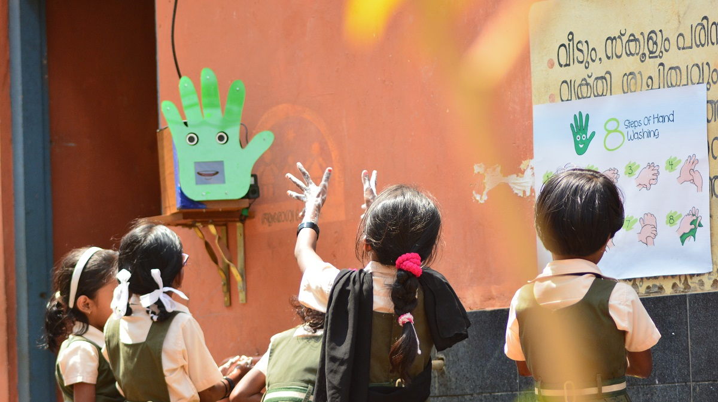
Fig. 1: Wall-mounted social robot giving instructions to children in a school

The unique aspect of this product is it provides totally unsupervised education and monitoring of handwashing behaviour which is done manually with current practices. Most technology-based hand hygiene interventions are expensive, they have targeted hospital care workers in developed countries and none have explored the use of interactive technology like social robots. The timing of our business solution is very relevant to the COVID-19 situation and can potentially create a very high impact by reducing the number of cases by boosting hand hygiene compliance. The IP protection planned during the fellowship on hand tracking algorithm using machine learning which would recognise the 6 steps of handwashing and give feedback to the user using gamification approaches would help to mitigate the concept being copied.

Estimated low-volume manufacturing cost of this product is about £200 but we plan to retail it for £500. We anticipate a high-volume manufacturing cost will be significantly lower at about £125-£150. The business will employ a social enterprise one-for-one business model, which means that for every robot bought in a developed country, the enterprise would give a subsidised (half the retail price) robot to a school in a developing country. The underlying computer vision technology could be turned into a mobile app for wide-scale download and a subscription-based service and in-app purchases for £0.99 for advance level. Another goal which will be explored during the fellowship is to tie a service to this product in its future iterations which is relevant for the customer's demands. An initial developed market is the UK, which has about 32,000 primary and secondary schools with about 9 million pupils. The business will also target schools in developing countries like India with 1.5 million schools where the impact of the technology can be more profound. There is are also a potentially large additional mark in nursery schools and kindergartens. This requires further work to investigate whether a modified version of the robot software could be used to help instill good early years training of children in effective handwashing. This training would then be reinforced as the children progressed to primary school. This would be explored in more detail in the course of a fellowship

12. | The market (250 words) • What is the size of the market opportunity that your company will address? Please specify a relevant market segment rather than the market as a whole. Concrete market data should be supplied where available.  • What are the relevant trends in this market, and where are users located geographically?  • Will the market be in a position to take up your technology, service or business proposition?
The business will target schools authorities, public health care organisations like NHS, children’s hospital, primary care centres, NGOs involved in hand washing interventions. The business aims to impact developing countries like India, which has the world’s largest rural population of 850 million and 1.5 million schools, with only 15% practising handwashing with soap. The annual net costs to India from not washing hands are estimated at US $ 23 billion, a national handwashing program in India could provide an estimated 92-fold return on investment [5]. In the UK with 32,000 schools, a survey by the London School of Hygiene & Tropical Medicine showed that only 63.8% of primary school and 39% for secondary school children regularly washed their hands with soap. The total annual cost for treating children with infections in primary care was estimated to be £757 million in the UK [6]. A hand hygiene intervention could bring estimated savings ranging from £106 to £387 per child per year in the UK [6]. Based on these figures, a conservative market share of 5% (1,600 schools) from a total of 32,000 Schools in the UK can generate a revenue of £800,000 at retail price of £500/unit, impact upto 500,000 pupils and bring an estimated saving of £50 million/year on health costs. The table below summarises the market size and potential revenue based on the number of schools in various regions of the world. There are estimated to 1.5 billion enrolled school children globally in primary and secondary schools.

Market Share | UK £ | Europe £ | US £ | India* (£250/unit) | Total Revenue £
1% | 160,000 | 1,375,000 | 664,265 | 3,75,0000 | 5,949,265
5% | 800,000 | 6,875,000 | 3,321,325 | 18,750,000 | 29,746,325
10% | 1,600,000 | 13,750,000 | 6,642,650 | 37,500,000 | 59,492,650
20% | 3,200,000 | 27,500,000 | 13,285,300 | 75,000,000 | 118,985,300
Total Schools | 32,000 | 275,000 | 132,853 | 1,500,000 | 1,939,853
*Please note price of the product for developing country like India is calculated as £250/unit (half the retail price)

The handwashing robot can also be positioned by the Newco as a high value bathroom/sanitary product. To put these figures in a broader context the global bathroom accessories market (rails racks, fittings etc) was $19.4 Billion 2017 and is growing at 5.4% CAGR [7] while the sanitary market (mainly porcelain appliances) was $9.2 Billion in 2017 and will grow to over $13.5 Billion 2025 [8]. This opens up multiple avenues for cross marketed and or distribution of the robot by manufacturers or retail distributors seeking to enhance their brand by supporting socially responsible products. Exploring and developing an optimal product positioning and marketing strategy would be a key benefit of RSE Fellowship support.

[5] https://onlinelibrary.wiley.com/doi/pdf/10.1111/tmi.12808
[6]https://www.birmingham.ac.uk/Documents/college-mds/haps/projects/WMHTAC/REPreports/2006/Handwashing.pdf
[7] https://www.hexaresearch.com/research-report/bathroom-accessories-market
[8]https://www.hexaresearch.com/research-report/bathroom-accessories-market

13. | Competitive advantage (250 words) • What is your unique selling point? What place will your product or service have in your intended market(s)?  • Who are the competitors in the marketplace, and how do they address the market’s needs? How do you compare?
In developing countries hand hygiene interventions mostly focus on educating people about health, germs and disease often using tools such as games, radio/TV campaigns, books, songs, posters, leaflets and charts. Such methods can be very resource/labour intensive and cumbersome to monitor at scale, measurements are unreliable due to self-reporting, and these approaches rarely result in positive, sustained behaviour change. In developed countries, hand hygiene interventions have investigated the use of electronic message boards, visual and audio prompts as a reminder to perform hand hygiene, emoticon-based feedback and vision-based system for tracking people’s activity in hospitals with some degree of success. The state-of-the-art technology developed by market leader in this domain, SureWash (www.surewash.com) uses computer vision technology for hand hygiene training to hospital staff, costs about £30k, it is bulky, works only in indoor environments and has limited interaction capabilities. There are no current commercial applications that achieve the same functionality as our product, so we would have first to market advantage.

Our robot also has been trialled in the real world and showed a 40% increase in the levels and quality of handwashing which sustained 6 days after the robot was removed. Our product offers a unique low-cost, portable, easy to scale and autonomous solution compared to all options available in the market right now. I am also an expert in this field and have the scientific and technical knowledge to develop this technology further as per changing market trends. The initial deployment in rural schools in India has already gained a lot of attention from the media [1, 2, 3].
[1] https://www.bbc.co.uk/news/av/technology-51360642/could-a-hand-washing-robot-help-save-lives
[2] https://www.ndtv.com/science/meet-pepe-hand-washing-robot-inspiring-students-on-sanitation-2119164
[3] https://healthcare-in-europe.com/en/news/handwashing-robot-helps-schoolkids-break-bad-habits.html

14. | Users/customers and their needs (250 words) • Who is the end user of the product/service, and what problem do they have that will be solved by the product/service?https://docs.google.com/document/d/13hyDZ14Agwwx_Ur3VSj68xVPsQ6taCtf_Pk-RRQWVFs/edit?usp=sharing  • Who are the customers (if different from end users) for the product/service?  • What evidence is there that customers will pay for this product or service at commercially profitable levels?  • What is the preferred route to market, and what channels will be used to reach customers?  • Have you already spoken to potential customers? What have you learned from them? Do you have early sales leads to follow up?
Existing practices for hand washing interventions face three major problems: (i) they are very resource intensive, (ii) complex to measure/monitor compliance at scale, and (iii) they rarely are sustainable over long-term. Our product offers a multi-disciplinary and innovative approach for influencing sustainable handwashing behaviour (24X7, 365 days a year). The main users of this technology are school children aged between 4-13. However, we recognise that the main target market are budget holders such as educational head teachers, school boards and local health administrators at the interface between education and public health. There is also a potential for this product to be used for adults, in public restrooms, restaurants, pubs/bars and shopping malls (over 75% of people either don’t wash their hands at all or don’t use soap to clean their hands properly).
The business-to-business (B2B) model will target the customers (mainly school authorities) and retail the product online through our website and also creating partnerships with suppliers like BESA (British Educational Suppliers Association), which constitute around 80% of the market in terms of the amount spent by UK schools on products and services. In our survey with 45 children during our pilot study [1], 97% of the respondents indicated that they wanted to see the robot again, and 91% respondents indicated that they like the robot “very much”, 72% of the students thought the robot was alive. The School teachers were also very supportive with the idea and said they would like to have it in the school.

[1] https://www.psy.gla.ac.uk/~amold/papers/2019/Ro-Man-Hand_washing_Perception.pdf

15. | The team, partnerships and connections (250 words) • Who else will be involved in developing your business? What are their roles?  • What partnerships will support the development of your business? How much do you still need to do to develop these partnerships?  • What broader connections do you envisage helping the development of your business?
I have formed partnerships and connections with the following in regard to taking this technology forward.

- I have an established partnership with Amrita University and their team in India, who are engaged in technology interventions and community development activities in over 142 villages and schools in India.

- The CEO and founder Patrick Meier of WeRobotics (https://werobotics.org/) has offered to facilitate deploying this technology with their network of partners across 25 developing countries.

- I will get support/guidance from the TTO and entrepreneur in residence, John Gordon, Commercial Director at University of Glasgow, College of Medical, Veterinary and Life Sciences.

- Dr Anna Lito Michala, lecturer with the school of computing science at University of Glasgow and former RSE Enterprise Fellow. Will act as a mentor on Start-up business processes in the space of Computer science and Technology.

- I have received a positive response from those involved in building the National ROBOTARIUM (https://www.edinburgh-robotics.org/robotarium opening 2021) and they are enthusiastic about my work as a possible HRI showcase, alongside the other social robotics work currently being investigated at Heriot-Watt University, Edinburgh, UK.

- Public Health Foundation of India (https://phfi.org/), an independent public-private initiative whose vision is to strengthen India’s public health also has connections with 26 rural schools, have shown interest to collaborate.

- Development Alternatives (DA) India (https://www.devalt.org/Aboutus.aspx), one of the first social enterprises dedicated to sustainable development, with a network of 50 rural schools across 2 states in India.

- Dr Ruchi Saxena, India Flying Labs Director (https://flyinglabs.org/india/), is a global health systems consultant who has extensively worked in the field of healthcare quality, remote health monitoring and helped various healthcare organisations, both private and non-profit in developing core systems, protocols, and processes.

- Currently connecting with schools across UK.

16. | What do you expect to achieve during the award? (250 words) • What progress do you expect to make with your business during your Enterprise Fellowship year?  • How will you know if you have been successful?
I would work towards refining the product to industry standards, get IP protection and patent during the fellowship. Register the business, build a team to scale up the business. Establish a production plan with manufacturers, preliminary discussions have already taken place with Industrial designers (https://intellore.com/). I will receive mentoring and guidance from RSE’s network of partners in the business community during the fellowship. Learn how to develop the business through this fellowship’s training programme. Conduct a detailed market survey and demonstrate the product to prospective customers.

I would seek funding from crowdfunding (https://www.indiegogo.com/), angel investors, seed funders, Scottish Enterprise and also through participation in start-up challenges like Converge impact challenge. The business idea has been shortlisted (only 14 candidates in the UK) for SUCESS program by ASPECT (https://aspect.ac.uk/) who are providing the training for developing businesses and a chance to win up to £50,000 in prize money to put toward the development of the business. I will hire a programmer and a design engineer to refine the product. A business developer/consultant to identify prospective customers and build relationships.

I would exhibit the product at trade shows and expos like CES (biggest consumer technologies show) to demonstrate the application to the general public and other businesses. However the UK market strategy and business development requires more work and RSE fellowship will help to develop this business. By the end of the fellowship achieving TRL-7 for the product, submitting a funding application to SMART award, and securing an order of 100 units will be a positive start to the business.

17. | What research, technology or innovation underpins the commercial offering of your proposed business? (500 words) What particular research, technology or innovation underpins the commercial offering of your proposed business?  Describe the technology or innovation at the basis of your application and how it will support your plans for your business.
In behavioural science, it is understood that people change their behaviour when they know they are being watched, also known as “Hawthorne Effect”. Building on this premise, the business idea proposes an unprecedented and novel approach to hand hygiene education and monitoring by developing a social robot as tools for persuasive technologies that can interact with people and be effective to change their behaviour. There is strong scientific evidence that the physical presence of a robot impacts human perception and influences behaviour in comparison to a screen based agent. Handwashing education and practice in schools is an effective way of reaching children and teaching them the habit of handwashing at a young age. Our approach focuses on the use of gamification which has shown positive results in technology based education and health related contexts. Gamification is the process of including game-like elements that could motivate and influence human behaviour to enhance learning. Previous research in developed countries has shown that robots in education could motivate children to learn better. Both extrinsic and intrinsic motivation to wash hands can be influenced by our social robot augmented with gamification strategies. Especially coming to rural schools in developing countries have limited exposure and access to different technologies due to their geographically remote and reduced economic background. Our application could potentially create a positive impact in their lives.

A proof-of-concept pilot study (Fig. 1) in a rural school in India showed the physical presence of a robot does impact human perception and influence handwashing [1, 2]. The pilot study showed encouraging results: a staggering 40% increased level of hand washing with soap and with a better hand washing technique. The social robot would educate, monitor and encourage hand washing behaviour in a fun and engaging way.
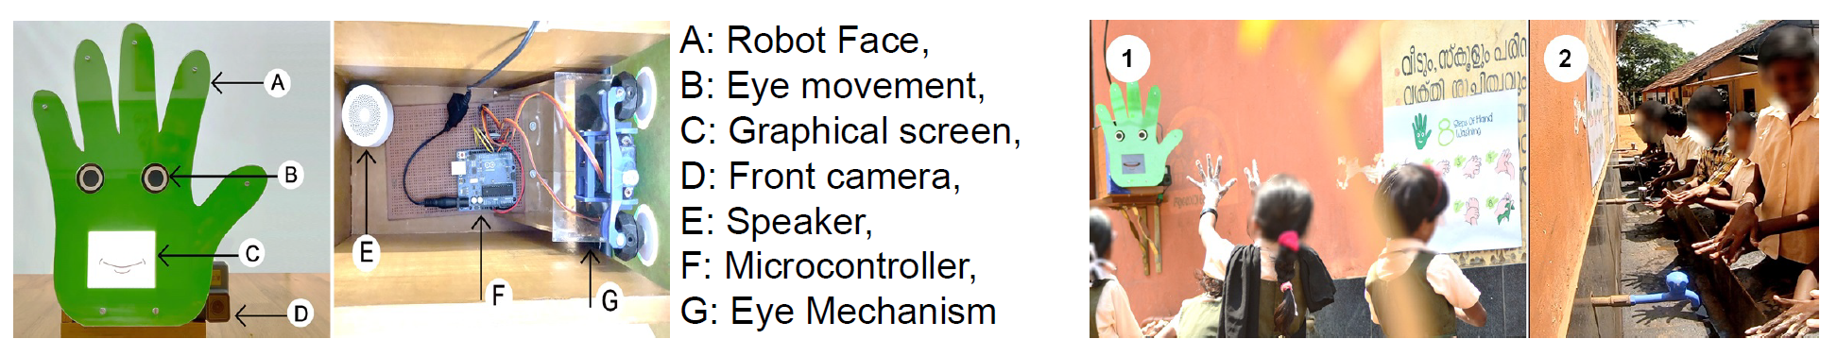
Figure 1: Image Left: Prototype Robot Design; Image Right: The wall mounted social robot near the water tap encouraged around 100 children to wash their hands via a poster on the wall. Video link: https://www.youtube.com/watch?v=DBFy3LI890s

The computer vision algorithm tracks people and their movement using machine learning approaches. Moreover the hand tracking algorithm is capable of providing the metrics and estimates of hand movement to determine an overall score on how well the hands were washed following the 6 steps of the WHO hand hygiene technique. The social robot has eye movement to track users and display emotions e.g. happy, sadness, disgust. A graphical screen to display graphical mouth to display smiles, frowns and a loud speaker for sounds and speech synthesis. Gamification strategies include for example, if the children wash their hands effectively, a time based graphic in relation to the handwashing steps completed is shown on the screen (e.g. balloon bursts or a rocket fires). Verbal and non-verbal feedback strategies using social reinforcement are used (e.g., the robot expressing social praise by saying “You are doing a great job, keep it up” while showing a happy expression and sounds). The shape, colour, size, eye design and material qualities of thel robot have been customised specific to hand-washing intervention grounded in scientific literature.

As computing technologies are constantly evolving, the business will take advantage of this dynamic development. By adopting state-of-the-art computer vision and machine learning techniques using deep learning and using latest high-performance embedded systems platforms the business will be well placed to provide the best possible solution at a low-cost.
[1] https://www.bbc.co.uk/news/av/technology-51360642/could-a-hand-washing-robot-help-save-lives
[2] https://www.psy.gla.ac.uk/~amold/papers/2019/Ro-Man-Hand_washing_Influence.pdf

18. | Market readiness (250 words) • Is the research, technology and innovation developed to the point that it is ready to be taken up by the users and/or the market?  • How close are you to having a completed product or service ready for market?  • What, if any, further development is required?  • How will that development be funded and resourced?
The prototype design is ready and the computer vision system can track hand motions (fig. 3). The current stage of development is TRL-4, as this has been tested in a real environment. However, the autonomous capabilities for the social robot needs further development. The hand tracking algorithm needs more data for training to work accurately in diverse physical environments. The hardware is using Raspberry pi but other cost-effective and computationally powerful single board computers will be tested. The game engine requires additional graphics/contents to make it more engaging for children. The plan is to run a user trial in a school to collect more data. The data collected from trials will be used to refine computer vision algorithms and the product design. We would contract an industrial designer to refine the product to industry standard (TRL-5). We will also perform necessary optimisation of software algorithms and benchmarking to reduce computational load and increased battery life. After refining the product, it will be demonstrated to relevant stakeholders and customers (TRL-6).

I am seeking funding support to run the trial in a school. For the initial hardware testing and upgrades, currently I have personally invested upto £500. I shall also seek to use the £5K business support funding from RSE fellowship for patent application and refinement of the product. The business is not set up yet it will be registered in due course. I will apply for Scottish Enterprise High Growth start-up funding via University of Glasgow network and participate in start-up funding competitions like Converge, ASPECT challenge, and Innovate UK.

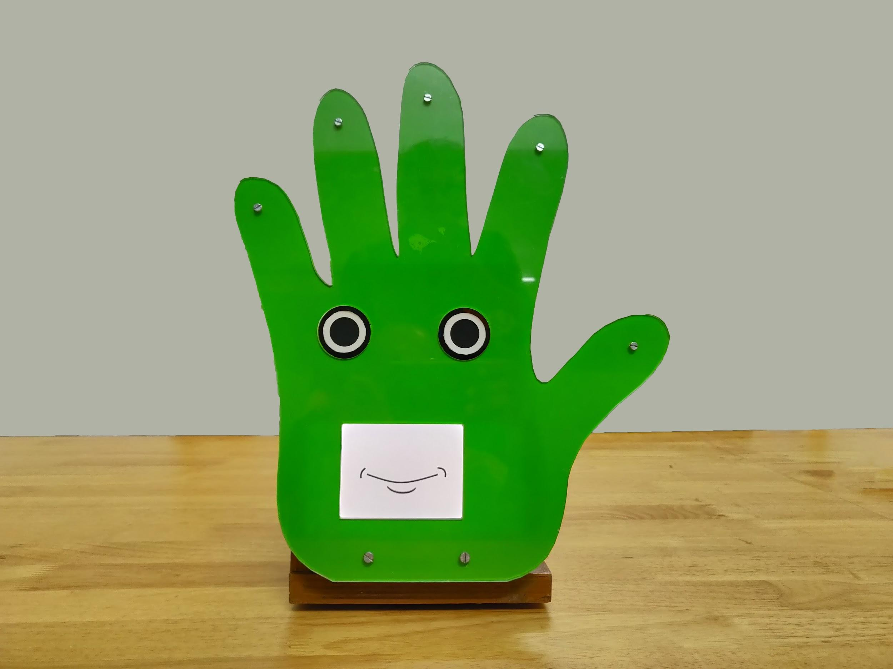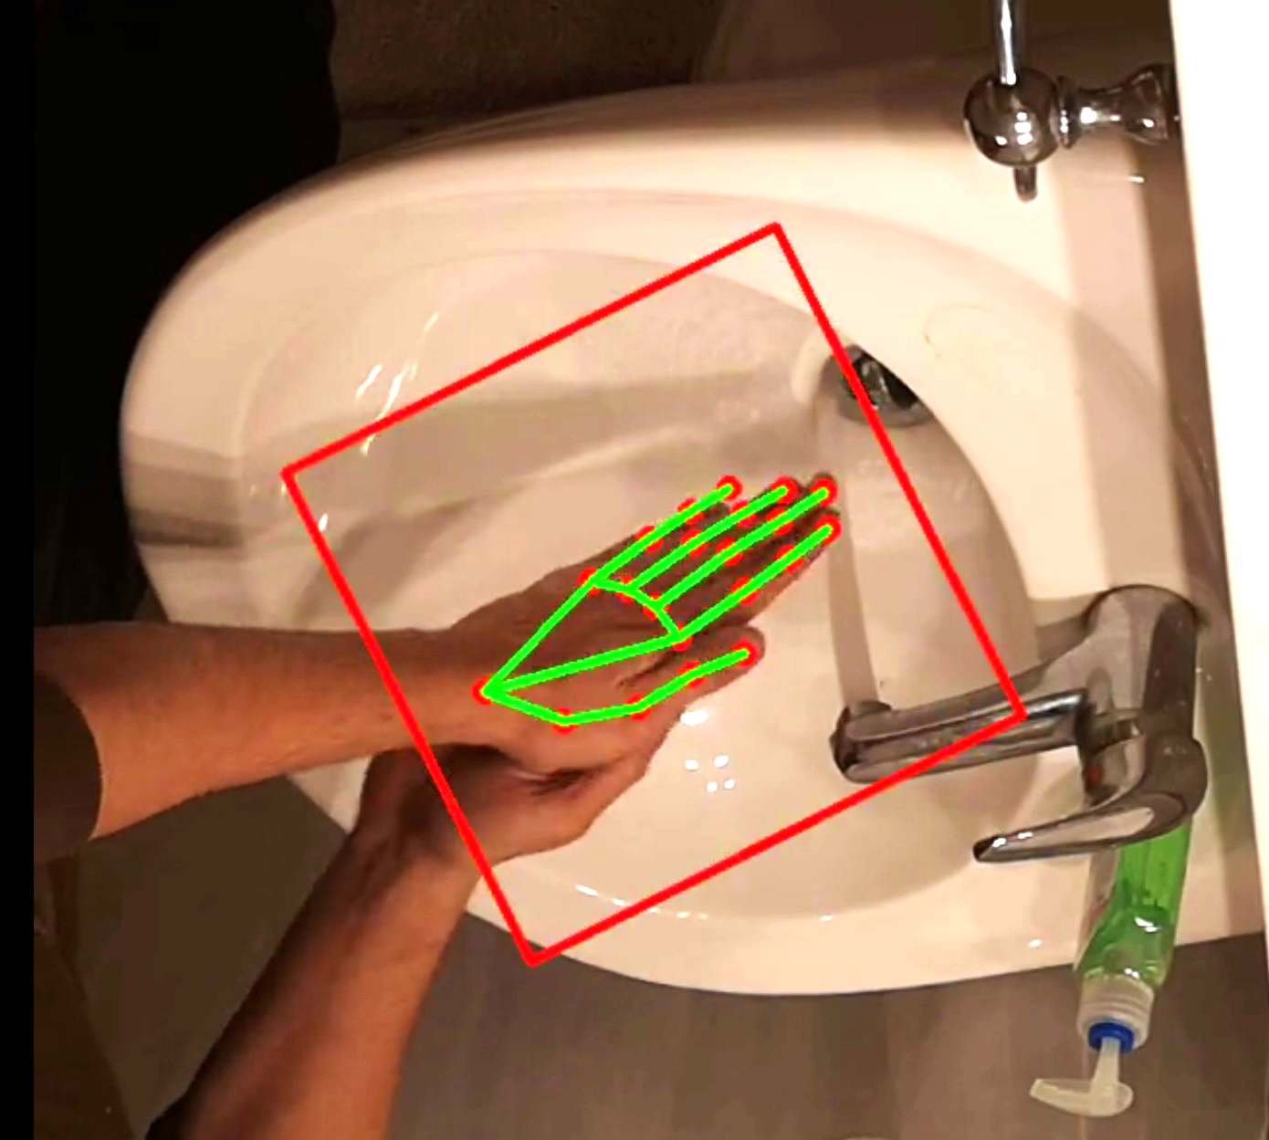
Fig. 3: Left: Prototype Design, Left: Tracking hand movement using computer vision, video https://www.youtube.com/watch?v=DBFy3LI890s

19. | Impact or commercial viability (250 words) • What evidence do you have to give confidence that the proposed offering is a solution that could be commercially successful or impact on policy and society?  • What market research have you conducted?  • What market reports support your proposition?  • What feedback do you have from potential customers, end users or industry experts?  • What impact will your technology have on society or policy?
The robot has been trailed in a rural school in India with success and showed a 40% increased levels and quality of hand washing with soap. The teachers in the school showed great interest to have the robot in the school. I have already received interest from Wash United (https://wash-united.org/) and NGOs from India (https://flyinglabs.org/india/), Nepal, Africa and Bangladesh who are willing to deploy the technology with their established network with schools. Although market surveys from Schools in the UK could not be completed due to school closures underlying COVID-19 circumstances. The RSE fellowship will help to refine the market research and connect with relevant stakeholders through its network.

Impact on society:
Our venture will bring economic, social and health benefits to communities. Our solution can contribute towards meeting the UN's sustainable development goal targets around sanitation, hygiene, education, nutrition and child survival in developing countries. The robot has a great potential to serve a supportive role in large scale health interventions both as active agents of behaviour change as well as objective assessors of various indicators of health and hygiene. This project will also help inform design decisions for robotic products that seek to address the underserved populations of the world, promote social inclusion and help bridge the digital divide. The business will also create new employment opportunities in the UK and will help to ensure the UK's leadership in the development of social robotics, bringing innovation within key industry and public health sectors.

Impact on policy makers:
I am also connecting with health authorities and policy makers to get feedback from them. An email response from Scottish Government Minister, Lara Allan Chief nursing officer, dated 16th March 2020 emphasised "The social robot looks like an interesting and creative concept to encourage effective hand-washing by children, which is particularly important in the current climate." I shall also seek to connect school authorities, policy makers and other stakeholders, for example, public-private partnership with companies like Unilever (Lifebuoy) who are engaged in handwashing programmes worldwide.
20. | Has the company the applicant seeks to develop during the enterprise fellowship been incorporated?
Yes ☐ No ☐ ✓

If YES, when was the Company incorporated?

Name of the Company:

Company Registered Number:

21. | Do you wish to undertake the enterprise fellowship on a part-time basis?
 | Yes ☐ | No ☐✓
If YES, then please address the following: -

- The timing to market for your technology

- How advanced your technology is

- Your circumstances that require you to undertake the Fellowship on a part-time basis

SECTION D: INTELLECTUAL PROPERTY RIGHTS

22. | Patents Please give details of any patent applications made, patents pending and patents already granted.
 | I Intent to apply for a patent during the fellowship.

23. | Does your application for an enterprise fellowship require access to any background IPR? Does your application for an Enterprise Fellowship require access to any background IPR? If yes, then clearly detail the background IPR required and its status (granted patent, patent filed know-how etc.). Refer to the Terms & Conditions for definitions and clarification regarding IPR.
 | Yes ☐ | No ☐✓
If NO, then go to Question 30.

If YES, then please clearly detail the background IP required and its status (granted patent, patent filed, know-how etc.)

24. | Who is the background IP owner?
 | Myself ☐ | Host Institution ☐ | Third Party ☐

25. | Has a written agreement regarding access to the IPR been reached with the owner of the IPR, detailed above?
 | Yes ☐ | No ☐
If YES, then please provide details of the nature of the agreement.
If NO, then please provide status and details of discussions underway.

26. | Please define the background IP to be exploited during the fellowship

27. | Has the IPR required for this Enterprise Fellowship application been licensed to any organisation or person?
 | Yes ☐ | No ☐
 | If YES, please give details and status

28. | Supporting statement from Technology Transfer Officer (or equivalent) Please see Application Guidance.
I confirm that I/we have discussed with the applicant the institution’s relevant
policies (e.g. IP and/or commercialisation) and the implications for
the proposed business (please tick the box).

Name :
Position:
E-mail:

29. | Background IPR statement (to be completed by the Host Institution)
a) | Please confirm whether written agreement on background IPR has been reached between the applicant and the IPR Owner:
 | Written agreement on Background IPR in place  Not yet agreed  The background IP is owned by the applicant |  | ☐  ☐  ☐
b) | I have read this application and the accompanying Guidelines and Terms & Conditions and agree that if an RSE Enterprise Fellowship is awarded to the applicant, the IPR Owner will grant rights to the detailed background IPR to the Enterprise Fellow in accordance with the Guidelines and Terms & Conditions. Where the applicant owns the background IP the host institution must sign below to confirm this.
 | Signature:  Name:  Position:  Email:  Institution with address: | Date:

30. | Foreground IPR statement (to be completed by the Host Institution) This statement must be signed by a senior member of the Host Institution's Commercialisation Office.
a) | Please confirm whether written agreement on foreground IPR has been reached between the applicant and the Host Institution by ticking the appropriate box below:
 | Written agreement on Foreground IPR in place  Not yet agreed |  | ☐  ☐
b) | I have read this application and accompanying Guidelines and Terms & Conditions and agree that if an RSE Enterprise Fellowship is awarded to the applicant, the Host Institution will grant rights to the detailed Foreground Intellectual Property Rights to the Enterprise Fellow in accordance with the Guidelines and Terms & Conditions.
 | Signature:  Name:  Position:  Email:  Institution with address: | Date:

SECTION E: OTHER SUPPORT OR FUNDING RECEIVED OR SOUGHT

31. | Are you actively seeking funding from other sources? Provide details of all other sources of funding you are actively seeking.
 | Yes ☐✓ | No ☐
If YES, please give details.
If NO, please give reasons.

Converge challenge, Aspect SUCCESS program, also planning to apply for investments from Scottish Enterprise and angel investors.

32. | Previous Research Council funding
Grant Reference:
Title:
Start date:
End Date:

33. | Support or involvement with our funders
 | Yes ☐ | No ☐ ✓
 | If YES, please give details

34. | De minimis public support, • Have you received de minimis public support in relation to the business you seek to develop through an enterprise fellowship, in the last three years?  • If YES, confirm the total level of de minimis support received during this period? (See the Terms & Conditions)  Have you received de minimis public support in relation to the business you seek to develop through an Enterprise Fellowship, in the last three years?  Yes No ✓✓  If YES, please confirm the total level of de minimis support received during this period?

35. | On-going support after the Enterprise Fellowship (150 words) • Where do you expect to be after the Enterprise Fellowship?  • Will you support yourself through your company sales or further investment?  • Will you expect to support yourself in some other way?
 | I will seek funding from private and angel investors to expand the business. I envisage to fund the business through these investments and also pre-sales orders by the end of the fellowship. If necessary I will not take a salary from the funding received to grow the business further.
SECTION F: FINAL SIGNATURES & THIRD-PARTY STATEMENTS

36. | Host Institution statement, This statement must be signed by the Head of the Department or Head of Business Unit of the proposed institution.
 | We have read this application and agree that if an RSE Enterprise Fellowship is awarded to and accepted by the applicant, this institution will be bound by the Guidelines and Terms & Conditions, will provide the necessary facilities, and will administer the Enterprise Fellowship.
 | Signature:  Name:  Position:  Email:  Institution with address: | Date:

37. | Applicant statement
 | I have read this application and accompanying Guidelines and Terms & Conditions, and I hereby apply for an RSE Enterprise Fellowship and agree that if I am offered and accept an Enterprise Fellowship that I shall be bound by the Guidelines and Terms & Conditions set out with this application form.
 | Signature:  Name: Dr Amol Deshmukh  Position: Research Associate  Email: amol.deshmukh@glasgow.ac.uk  Institution: University of Glasgow | Date: 3/04/2020

38. | Are you the inventor / principal investigator of the idea / research to be used as the basis for your application?
 | Yes ☐ | No ☐
If NO, please ask the inventor / principal investigator (PI) to complete the sections below.
If YES, please just sign the Inventor/PI statement.

TO BE COMPLETED BY THE INVENTOR / PRINCIPAL INVESTIGATOR

39. | Inventor / PI statement
 | I have read this application and the accompanying Guidelines and Terms & Conditions and fully endorse the application for an Enterprise Fellowship to commercialise the idea/research as outlined in this form.
 | Signature:  Name: Dr Amol Deshmukh  Position: Research Associate  Email: amol.deshmukh@glasgow.ac.uk  Institution: University of Glasgow | Date: 3/04/2020

RSE ENTERPRISE FELLOWSHIP
CONFIDENTIAL INVENTOR/PI REPORT

The inventor/PI must provide a confidential reference if he/she is not the applicant.

Name of applicant: Dr Amol Deshmukh
Title of business proposition: Handwashing robot
Proposed institution and department: Institute of Neuroscience and Psychology, University of Glasgow
Institution Address: University of Glasgow, Glasgow G12 8QQ, United Kingdom

I, the above-named applicant, have supplied your name and address as the Inventor/Principle Investigator and would be grateful if you could provide a confidential report below. The report should be included in the final application submitted.

Please insert comments here, including comments on the following:-

The technology being commercialised and its stage of development:
TRL 4, please refer Q. 18

Why the applicant is the right person to take this forward:
Please refer Q. 6

Your involvement, if any, in the proposed business during and after the Enterprise Fellowship:
I am the inventor, developer and business creator.

Inventor/PI'S details

SIGNED: | NAME: (BLOCK CAPITALS)  AMOL DESHMUKH
Relationship to the applicant (e.g. Supervisor): SELF

Relationship to the business proposition:

40. | DETAILS OF TWO REFEREES • Provide details of two referees. One of them must be the PI/Inventor if the applicant is not the PI/Inventor him/herself.  • Ideally both referees should be academic or business-related and should be people who know your business proposal and the product/technology. One reference can be personal if necessary.  • It is your responsibility to ask your referees to complete these sections of the Application Form.
 | - Name:Dr John Gordon  Email: john,gordon@glasgow.ac.uk  Telephone:0141 330 9769 | - Name: Prof. Helen Hastie  Email: H.Hastie@hw.ac.uk  Telephone: +44 (131) 451 3344

Reference 1

Name of reference: | Dr John Gordon reference for Dr Amol Deshmukh
Applicants proposed commercialisation project: | Handwashing Robot
Applicants proposed institution and department: | University of Glasgow, Institute of Neuroscience and Psychology College of Medical Veterinary and Life Sciences

As a guide, the Referee should cover the following: -
The applicants’ suitability to take forward the business proposition. (Please answer below)
In my capacity as Entrepreneur in Residence in the College and as an early past recipient of this fellowship myself consider Dr Amol Deshmukh to be an outstanding candidate for this programme. In the last few weeks my colleagues and I in business development support within the college and our central technology transfer office have engaged significantly with Amol in preparing this application.
It’s clear he is extraordinarily gifted in the multiple technical engineering notably robotics and computing required to build the prototype device. What is particularly impressive is that he has been willing and able to very effectively apply these technical skills within a completely different social sciences environment. This project is being developed in his present position within the Institute of Neuroscience and Psychology to address behavioral change and addressing important societal challenges in hand washing. This is not the first time he has used his technical skills to address a major water related societal problem. This current project builds indirectly upon an earlier large scale more engineering focussed project he carried out in a low resource setting before. That prior project taught him very valuable business and project management skills and lessons that he will apply in the present project.
Within the current as will be clear from the application he has shown an impressive ability to project the project in both social and mainstream media and identify and access additional sources of translational innovation funding. Working with him he has shown great willingness to learn from business development and technology support staff and to undertake market research and develop his entrepreneurial and business skills. Unlike many academics he has a genuine interest in these matters and he is absolutely committed to making this venture work. I think he is a natural technology entrepreneur and the RSE comes at precisely the right time in both his professional development and the project development.
There may be temptation to categorize this as a “social venture”. This is not the case. There is a clear unmet need and market need in both high income and low income countries and the basis of global business. The project is almost uniquely timely in the present circumstances. It has potential to create a high growth company in Scotland that has a global healthcare and societal impact. At the time of submission the whole handwashing and coronavirus scene is moving very rapidly. I believe with internal support from the University Dr Deshmukh will in the next two months make additional significant progress on further developing his market research and technical plans. Therefore by the time of any prospective interview either in person or online in the year his case for support will be compelling.

The applicants’ involvement in the development of the product/technology. (Please answer below)

The applicant has been the main inventor developer and delivery route for all of the various aspects of the project and the technology. While the University, the Institute of Neuroscience and Psychology have provided a supportive environment and advice where required, the intellectual basis and drive has come entirely from Dr Deshmukh. It should be noted that this project has been developed and delivered in addition to his funded project as a research associate in the college. His research associate project is focussed on computational modelling of social non-verbal behaviours for artificial agents. Clearly there is a balance to be struck between the two, but these issues have been addressed in other life sciences ventures through differential pricing for drugs in low income countries and a similar approach is possible here. Dr Deshmukh has managed his time working out of his normal research to build this business idea and I am positive that with his drive and passion he will deliver success through this venture.

The Referee’s relationship to the applicant and the business (there is a Declaration of Interest Form continued on this form which must be completed if the referee is to be involved in the business going forward) (Please answer below)

In my role as Entrepreneur in Residence within the college I routinely help advise academic Principle Investigators on technology and commercial matters. I often act in a role working with colleagues which helps progress of projects between translational research funding and early company formation. Key funding sources include RSE Fellowships and SE High Growth Start Up support as demonstrated recently with Professor Shireen Davies successful application last year where I was closely involved. In that case I continue to work closely with the TTO to help lay groundwork for company formation, patent filing, and raising series A funding. This is done as part of my normal business support role and does not involve my taking any equity or paid managerial role within the Newco.
Should this application be successful I would support its continued development in a similar manner and would therefore have no material interest or conflict to declare. Similarly I have no interest in commercial ventures which may benefit from this project.

Referee's details

SIGNED: | NAME: (BLOCK CAPITALS)  DR JOHN GORDON
Relationship to the applicant  (e.g. Supervisor): | BUSINESS DEVELOPMENT SUPPORT
Relationship to the business proposition: | BUSINESS DEVELOPMENT SUPPORT

DECLARATION OF INTEREST - REFEREES

- Individuals are required to declare any private, professional or commercial interests that might conceivably conflict with the interests of the funder, or which members of the public might reasonably think could influence or bias their judgement when offering references. Such interests will include company appointments, directorships, consultancies and honorary appointments.

- In most cases only current interests need be declared but it is possible that, on occasions, there may be suggestions that a past interest would or could influence present behaviour, in which case a continuation of a declaration of that interest may be appropriate.

Personal Remuneration

- Individuals must declare the names of any organisation or company which they receive personal remuneration from:
  - a university or research institute or similar body;
  - any directorships or employment or other connection with companies in any field where the company might benefit from support by the funder either as a collaborator in some other way;
  - any position of authority in charities and other bodies providing research funding;

- Where a pension is currently received (and possibly where it is to be received in the future) either from any organisation that falls within the categories listed above, or from a closely related body that manages its pension scheme, the name of the body, and the fact that a pension is or will be received should be declared.

Shareholdings

- Individuals must also declare any shareholdings or other financial interests in companies or bodies listed (above). However, holdings in unit trusts, investment trusts, Open Ended Investment Companies (OEICs), unit linked policies, pension schemes or similar arrangements under which the investor has an interest in a large number of enterprises, need not be disclosed unless they specialise in higher technology companies in the field of the Council, and have a market value of greater than £10,000. Shareholdings, debentures, options and similar rights in a single company listed on the main market of a recognised stock exchange with a market value of less than £10,000, need not be disclosed unless they are known to benefit as participants in collaborative research or other projects funded by the funder, or are known to be significant suppliers of goods and services.

Non-Pecuniary Interests

- Individuals should declare any unremunerated involvement with any body in connection with any activity with the funder, including relevant:
      - appointments at a university or research institute or similar body;
      - directorships or employment or other connection with companies in any field where the company might benefit from support from the funder either as a collaborator or in some other way;
      - positions of authority in charities and other bodies providing research funding.

- Except where they come within the scope of the above paragraph, membership of clubs and associations need not be registered.

- The university and department, or institute, or company, or similar body of any of the individual’s significant collaborators outside of the member’s own institution or organisation, and the nature of the relationship, e.g. research collaboration, should also be included under this heading. The smaller the number of collaborations and the larger the project, the greater the need for disclosure. For example, fellow principal investigators in major projects need to be disclosed, but in most cases there would, for example, be no need to disclose the names of collaborators in large multi-centre trials or the names of all industrial partners in a large collaborative project unless the collaborator was involved in a specific and significant piece of research with them.

Research Income

- Individuals should also declare sources of any research funding that they are currently receiving. Bodies supported by the funder or which benefit as collaborators or licensees, etc, from which income is received should be declared, however small the amount. The size of the sum need not be closely quantified or declared.

REGISTER OF PRIVATE, PROFESSIONAL AND COMMERCIAL INTERESTS THAT MAY POTENTIALLY CONFLICT WITH FUNDER BUSINESS

Name

Name of employing body

Position

Name of Enterprise Fellowship Applicant

Please give below details of all private, professional or commercial interests that might conceivably conflict with the interests of the funder.

Personal Remuneration (please identify bodies or companies from which you receive a personal remuneration including a salary)

N/A

Shareholdings (please declare relevant shareholdings or other financial interests)

N/A

Non-Pecuniary Interests (please declare any unremunerated involvement with relevant bodies)

N/A

Research Income (please declare the sources of any current research income)

N/A

SIGNED:

NAME: (BLOCK CAPITALS)  DR JOHN GORDON | Date: 3/04/2020

Reference 2

Name of reference: | Professor Helen Hastie
Applicants proposed commercialisation project: | Handwashing robot
Applicants proposed institution and department: | University of Glasgow, Institute of Neuroscience and Psychology College of Medical Veterinary and Life Sciences

As a guide, the Referee should cover the following: -

The applicants’ suitability to take forward the business proposition. (Please answer below)

I am a Professor in the Computer Science department at Heriot Watt University and the Director of the EPSRC Centre for Doctoral Training in Robotics and Autonomous Systems. I have worked with Dr Amol Deshmukh during the period of 2013-2016 on the EU-funded project EMOTE on robot tutors that understand the learner's state and adapt, offering a new and exciting approach to learning. On this project Dr Deshmukh demonstrated excellent technical skills, developing human-robot interaction algorithms and successfully conducting experiments with children using robotic tutors in Scottish schools. This work resulted in a number of publications including conference proceedings of AAMAS, ICSR and ICMI.
I highly recommend Amol for the RSE Enterprise Fellowship as he shows a unique ability to perform research and development but, importantly, has the foresight to understand real world applications.

The applicants’ involvement in the development of the product/technology. (Please answer below)

I highly recommend Dr Deshmukh for this programme, not only because of his technical ability but also because of how he can understand how his fundamental work on robotics can further be developed to solve real world problems, as is exemplified in his business idea of a hand washing robot. This is even more fitting in today’s ever-changing world where handwashing is so key to combating the spread of the COVID-19 virus and thus his project has the ability to be successful from a financial point of view but also save lives and have huge benefits to the community.
Dr Deshmukh has excellent problem-solving skills and experience with software development, with machine learning and computer vision, as is exemplified by his work on various European projects including Emote for Robotic Tutors and Mummer for Robotic Shopping Mall assistants. I am confident that with his passion and determination he will be successful with his entrepreneurial journey.

The Referee’s relationship to the applicant and the business (there is a Declaration of Interest Form continued on this form which must be completed if the referee is to be involved in the business going forward) (Please answer below)

I look forward to supporting this journey alongside the other social robotics work currently being investigated at Heriot-Watt University and the National Robotarium. Please contact me if I can provide any additional information.

Referee's details

SIGNED: | NAME: (BLOCK CAPITALS)  HELEN HASTIE
Relationship to the applicant  (e.g. Supervisor): | Former Co-employee
Relationship to the business proposition: | Guidance and mentoring

DECLARATION OF INTEREST - REFEREES

- Individuals are required to declare any private, professional or commercial interests that might conceivably conflict with the interests of the funder, or which members of the public might reasonably think could influence or bias their judgement when offering references. Such interests will include company appointments, directorships, consultancies and honorary appointments.

- In most cases only current interests need be declared but it is possible that, on occasions, there may be suggestions that a past interest would or could influence present behaviour, in which case a continuation of a declaration of that interest may be appropriate.

Personal Remuneration

- Individuals must declare the names of any organisation or company which they receive personal remuneration from:
  - a university or research institute or similar body;
  - any directorships or employment or other connection with companies in any field where the company might benefit from support by the funder either as a collaborator in some other way;
  - any position of authority in charities and other bodies providing research funding;

- Where a pension is currently received (and possibly where it is to be received in the future) either from any organisation that falls within the categories listed above, or from a closely related body that manages its pension scheme, the name of the body, and the fact that a pension is or will be received should be declared.

Shareholdings

- Individuals must also declare any shareholdings or other financial interests in companies or bodies listed (above). However, holdings in unit trusts, investment trusts, Open Ended Investment Companies (OEICs), unit linked policies, pension schemes or similar arrangements under which the investor has an interest in a large number of enterprises, need not be disclosed unless they specialise in higher technology companies in the field of the Council, and have a market value of greater than £10,000. Shareholdings, debentures, options and similar rights in a single company listed on the main market of a recognised stock exchange with a market value of less than £10,000, need not be disclosed unless they are known to benefit as participants in collaborative research or other projects funded by the funder, or are known to be significant suppliers of goods and services.

Non-Pecuniary Interests

- Individuals should declare any unremunerated involvement with any body in connection with any activity with the funder, including relevant:
      - appointments at a university or research institute or similar body;
      - directorships or employment or other connection with companies in any field where the company might benefit from support from the funder either as a collaborator or in some other way;
      - positions of authority in charities and other bodies providing research funding.

- Except where they come within the scope of the above paragraph, membership of clubs and associations need not be registered.

- The university and department, or institute, or company, or similar body of any of the individual’s significant collaborators outside of the member’s own institution or organisation, and the nature of the relationship, e.g. research collaboration, should also be included under this heading. The smaller the number of collaborations and the larger the project, the greater the need for disclosure. For example, fellow principal investigators in major projects need to be disclosed, but in most cases there would, for example, be no need to disclose the names of collaborators in large multi-centre trials or the names of all industrial partners in a large collaborative project unless the collaborator was involved in a specific and significant piece of research with them.

Research Income

- Individuals should also declare sources of any research funding that they are currently receiving. Bodies supported by the funder or which benefit as collaborators or licensees, etc, from which income is received should be declared, however small the amount. The size of the sum need not be closely quantified or declared.

REGISTER OF PRIVATE, PROFESSIONAL AND COMMERCIAL INTERESTS THAT MAY POTENTIALLY CONFLICT WITH FUNDER BUSINESS

Name

Name of employing body

Position

Name of Enterprise Fellowship Applicant

Please give below details of all private, professional or commercial interests that might conceivably conflict with the interests of the funder.

Personal Remuneration (please identify bodies or companies from which you receive a personal remuneration including a salary)

N/A

Shareholdings (please declare relevant shareholdings or other financial interests)

N/A

Non-Pecuniary Interests (please declare any unremunerated involvement with relevant bodies)

Research Income (please declare the sources of any current research income)

N/A

SIGNED:

NAME: (BLOCK CAPITALS)  HELEN HASTIE | Date: 3/04/2020

Data Protection Consent

Personal data we receive about you through this application, or as a recipient of an Enterprise Fellowship will be processed by us in accordance with our Privacy Policy.

Before submitting ensure you have:

- Completed the online equal opportunities monitoring form. This form is automatically submitted on completion.

- Please refer to the front sheet check list to make sure you have completed everything necessary.

Thank you for completing this form and good luck!

